RISK ASSESSMENT POLICY
R.E.A.L FOUNDATION TRUST
SEPTEMBER 2021

Risk Management and Risk Assessment
The Company recognises that it has a responsibility to provide a safe and healthy working environment and acknowledges that this includes ensuring that all significant risks arising from work activities are adequately managed.
The Company will endeavour to comply with the relevant legal requirements, as contained within the Management of Health and Safety at Work Regulations 1999 and other applicable legislation, and with the specific Approve Code of Practice (L21) and guidance notes (HSG 65) issued by the Health and Safety Executive.
In particular the following rules and procedures will be applied in relation to this area or work activity:
(1) The Company will institute a programme of hazard identification and risk assessment of all its activities in order to eliminate, reduce or control, so far as is reasonably practicable, any harm or danger to employees or other affected persons.
(2) All risk assessments will be fully documented and recorded.
(3) All risk assessments will be reviewed annually.
(4) All risk assessments will be monitored on a regular basis at a frequency determined by, and stated within, the assessment.
(5) All relevant employees or other persons will be informed of the significant findings of risk assessments that relate to their work activities or otherwise affect them.
DEFINITIONS
Hazard A “hazard” is something that has the potential to cause harm.
Risk “Risk” is the likelihood of the harm being realised. The risk, therefore, reflects both the likelihood that harm will occur and its severity. It will generally be recorded as insignificant, low, medium or high.
Control Measures Where work activities, items or areas with significant risks are identified the risk assessment will contain details of the measures that must be applied or actions that must be taken in order to eliminate, reduce or control the risks in question and therefore allow the activity etc to be carried out safely.
These required measures or actions are referred to as ‘control measures’.
Hierarchy of Control Measures The following principles will be applied to adopting control measures: - Avoiding the risks altogether - Evaluating the risks which cannot be avoided - Combating risks at source - Adapting the work to the individual - Adapting to technical progress - Replacing the dangerous with the non-dangerous or less dangerous - Developing a coherent overall prevention policy - Giving collective protective measures priority over individual protective measures - Giving appropriate instructions to employees
Review and Revision The risk assessments must be kept up-to-date and be reviewed and modified, where necessary. If changes take place which mean that the current risk assessment is no longer valid or that it can be improved, the assessment must be reviewed. In all cases, risk assessments will be reviewed on a regular annual basis.
Information and Training All employees will be provided with relevant information regarding the risks to their health and safety as identified by the assessment, including information on the required control measures.
Record Keeping All significant findings of risk assessments and subsequent monitoring must be recorded. The records must include:
- The significant hazards identified in the assessment - those which might pose serious risk to workers or others who might be affected by the work activity if they were not properly controlled - The levels of risk associated with the hazards - The existing or required control measures - The people who may be affected by the risks or hazards, including any groups of employees who are at special risk - Decisions taken as a result of the assessment.
All task related risk assessments will be recorded using the following template (Risk Assessment Tool) and risk rating matrix:

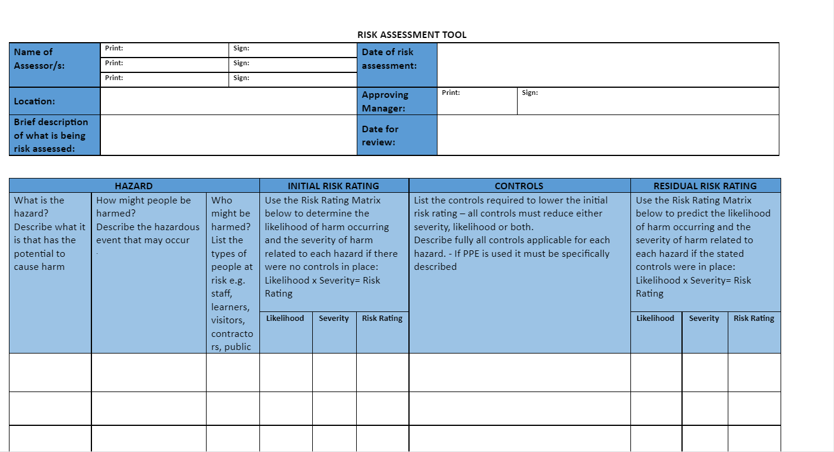

RISK RATING MATRIX AND DESCRIPTORS
Severity of Harm | Descriptor |  | Likelihood of Harm Occurring | Descriptor
1. Negligible | No injury or ill health |  | 1. Very unlikely | Little or no chance of occurrence i.e. it would require a freak combination of factors for the situation to result
2. Minor | Minor injury or ill health requiring first aid only |  | 2. Unlikely | Conceivable i.e. it is possible for the hazardous event to occur but unlikely under normal circumstances and would require multiple failures of systems and controls or a rare combination of factors
3. Moderate | Injury or ill health requiring up to 3 days absence |  | 3. Possible | The hazardous event could occur e.g. “ i’ve heard of it happening”
4. Critical | Injury or ill health requiring more than 7 days absence |  | 4. Likely | The hazardous event has occurred or is known to have occurred in a similar setting and/or is likely to occur on several occasions
5. Catastrophic | Multi-person injury/ill health; single person fatality and/or multi-person fatalities |  | 5. Very likely | It is almost inevitable that the hazardous event is likely to occur or be a frequent or common occurrence

RISK RATING |  | SEVERITY |  |  |  |  |  | ACTION LEVELS
 |  | 1.  Negligible | 2.  Minor | 3.  Moderate | 4.  Critical | 5.  Catastrophic |  | 1-6 Low | May be acceptable - However, due care must be taken to ensure controls are maintained reviewed periodically with a view to reducing the risk level at every available opportunity.
L  I  K  E  L  I  H  O  O  D | 1. Very unlikely | 1 | 2 | 3 | 4 | 5 |  | 8-12 Med | The task/activity should only proceed with appropriate authorisation - where possible the task/activity should be re-defined and/or additional controls implemented to reduce the risk level.
 | 2. Unlikely | 2 | 4 | 6 | 8 | 10 |  | 15-25 High | Stop task/activity immediately and seek competent advice.
 | 3. Possible | 3 | 6 | 9 | 12 | 15
 | 4. Likely | 4 | 8 | 12 | 16 | 20
 | 5. Very likely | 5 | 10 | 15 | 20 | 25

